**SQL Workbench Proof for AWS RDB Database: (Workbench connected to AWS RDB)**

No.of Records in state_institution:

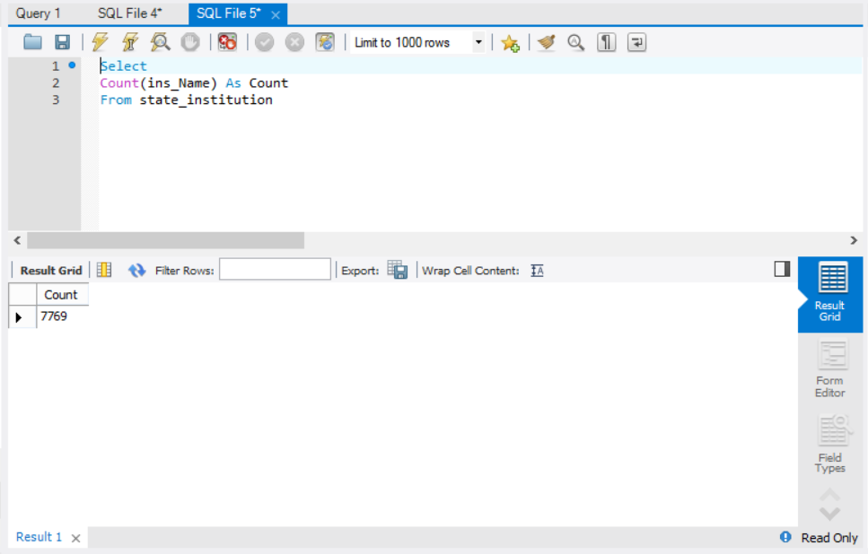

No.of Records in state_revenue:

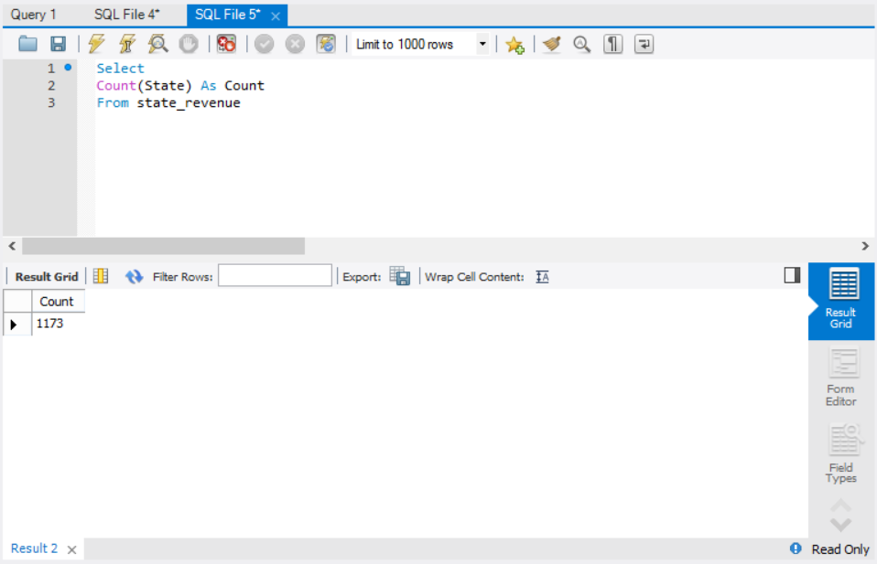

Sample set of records from state_institution:

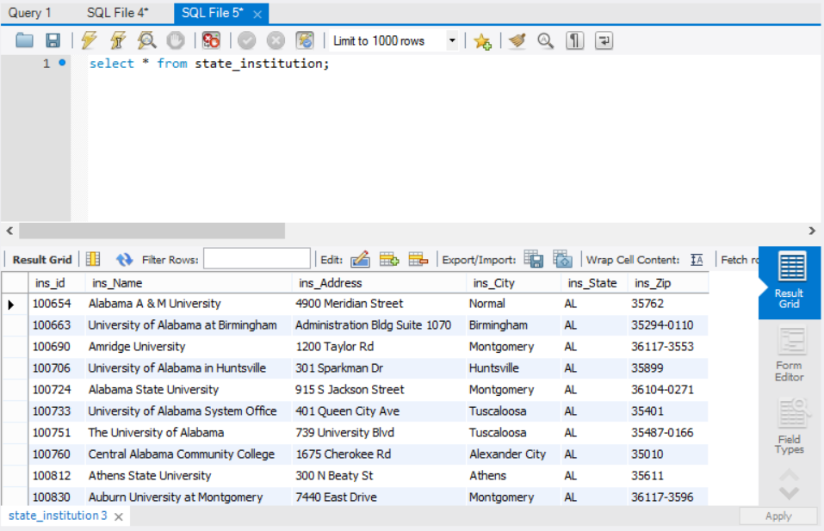

Sample set of records from state_revenue:

